VENANGO TECHNOLOGY CENTER
JOINT COMMITTEE
1 Vo-Tech Drive
Oil City, Pennsylvania 16301

MINUTES

March 2, 2020

The regular meeting of the Venango Technology Center Joint Committee was held this evening in the Conference Room of the Venango Technology Center, 1 Vo-Tech Drive, Oil City, PA 16301. Mrs. Neely called the meeting to order at seven o’clock (7:00) p.m.

Mrs. Neely asked the members to pause for a moment of silence.

Mrs. Neely asked the members to stand for the pledge of allegiance.

Roll Call: Present: Troy Johnston, Robert Blauser, James Come, James Disque, Misty Nalepa, Mark
Marterella, Jeff Thomas, Shari Neely

Absent: Todd Carson, Don Judy

Also Present: Mr. Mario Fontanazza, Dr. Lynda Weller

Mrs. Neely stated the Joint Committee members had received copies of the Minutes of the February 3, 2020 meeting in the mail. She asked if there were any additions, corrections or deletions.

Mr. Marterella, seconded by Ms. Nalepa, moved to approve the Minutes of the February 3, 2020 meeting as submitted.

Roll Call: Ayes: Troy Johnston, Robert Blauser, James Come, James Disque, Misty Nalepa, Mark
Marterella, Jeff Thomas, Shari Neely

Nayes: None, motion carried.

The Treasurer and Secretary’s Report as of 3/2/2020 Special Account report for 3/2/2020 were submitted for information.

Mr. Marterella, seconded by Mr. Blauser, moved to accept the Treasurer and Secretary’s Report and the Special Account report as of 3/2/2020 as submitted.

The motion was unanimously approved.

A list of bills from 2/4/2020 – 3/2/2020 in the amount of $418,207.73 was presented for approval.

Ms.Nalepa, seconded by, Mr. Marterella, moved to approve the list of bills as presented.

Mr. Adams answered some questions regarding the bills.

Roll Call: Ayes: Troy Johnston, Robert Blauser, James Come, James Disque, Misty Nalepa, Mark
Marterella, Jeff Thomas, Shari Neely

Nayes: None, motion carried.

Under Communications, Mr. Fontanazza discussed the Professional Advisory Committee minutes. He also discussed the Calendar of Events for the month of February and the Monthly Enrollment Report as of 3/2/2020 were submitted.

The Joint Committee entered executive session for personnel matters at 7:11 p.m.

The meeting reconvened at 8:13 p.m.

Mrs. Neely requested approval of the action items as presented. Item 8. a) ii. –vi. in one motion.

Mr. Johnston, seconded by Mr. Marterella, moved to approve action items 8. a) ii. –vi. as follows:

    - Approve additions to the Occupational Advisory Committees. No additions
    - Approve Oil & Gas Technology to be changed to Diesel Technology.
    - Accept successful bid on the HVAC Trainers from Allegheny education for $98,899.00.
    - Approve Tim Lyons to attend the Amatrol TableTop Mechatronics course in Jeffersonville, IN on May 31 – June 5, 2020 at a cost not to exceed $1,200.00. Funding – Local
    - Approve Travis Crate to attend the Lincoln Electric Cutting Systems training in Cleveland April 21 – 23, 2020 at a cost not to exceed $1,100.00. Funding – Local
    - Approve Mario Fontanazza to attend the PA Association of School Administrators Leadership Forum on March 29-31, 2020 in State College at a cost not to exceed $1,100.00. Funding – Local

Roll Call: Ayes: Troy Johnston, Robert Blauser, James Come, James Disque, Misty Nalepa, Mark
Marterella, Jeff Thomas, Shari Neely

Nayes: None, motion carried.

Mr. Fontanazza reviewed his Issues/Activities for February 2020.

Mrs. Neely reported that under old business the results of the voting on the Venango Technology Center Budget were included in the packet. Mr. Adams added that the vote was unanimous with the exception of those who were absent. He also mentioned that Valley Grove was down one Board member at the current time.

Mrs. Neely asked if there was any new business.

None was noted.

Upon motion by Mr. Marterella, seconded by Mr. Disque, the meeting adjourned at twenty minutes past seven (8:17) p.m.

Recorded by
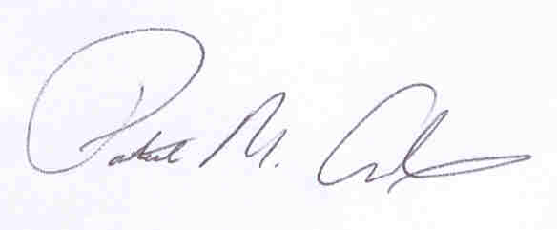
Patrick M. Adams
Secretary, Joint Committee

